Comprehensive Creative Technologies Project: How can developers improve the way new information is provided and retained with inexperienced players in video games?
Author Name
nicholas2.cornwell@live.uwe.ac.uk
Supervisor: Jack Ruskin

Department of Computing and Creative Technology
University of the West of England
Coldharbour Lane
Bristol BS16 1QY
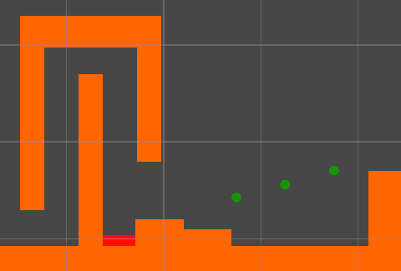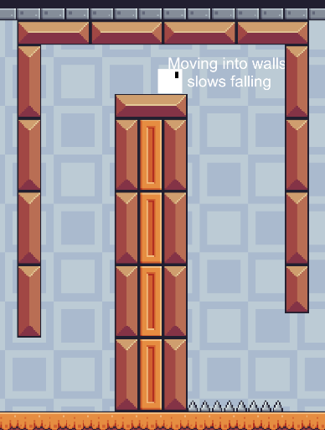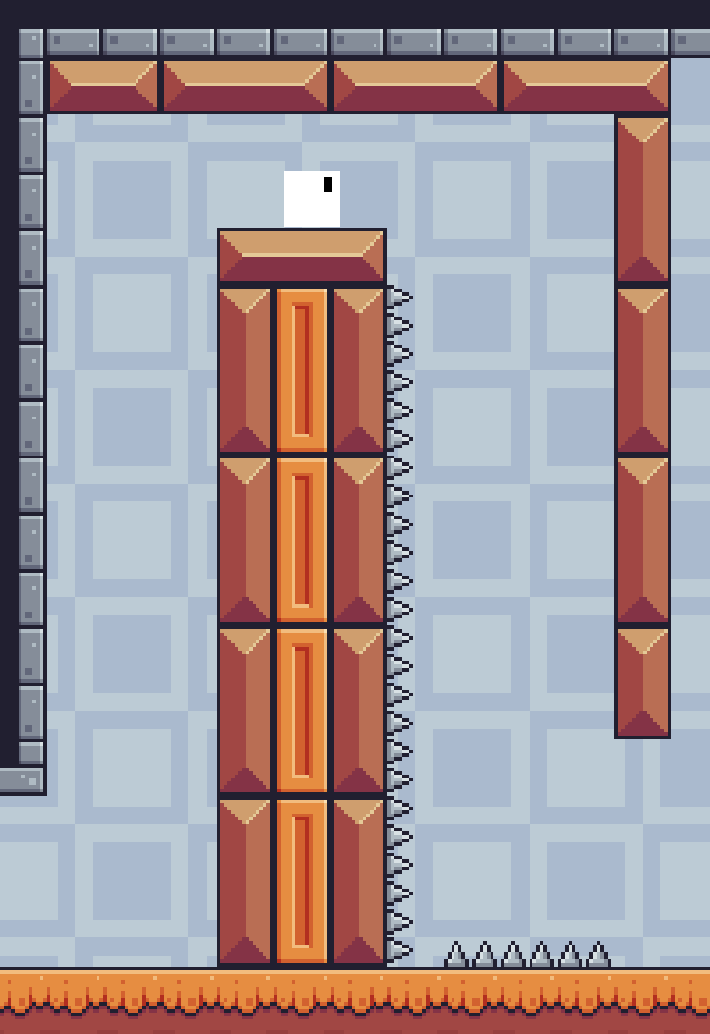

Abstract

This project looks into how developers can improve how they can present new information to players who are new to gaming or their game genre. The project uses Unity, a game development engine to make the artifact used for player testing and applying researched information. Player testing was used to find real world examples of player patterns in gaming which can be used to modify how the game shows the player how to play.
----------------------------------------------------------------------------------------------------------------------
Verdana, 9pt. This is a top line description of your project, not an introduction (that comes later). Please summarise your project, giving a bird’s eye view of your application/ software/ animation/ etc.
What is the project? What is its aim? How was this realized in practice? Any key results/ insights that might benefit other professionals in the field? Don’t try to write anything new here, just repeat the main points achieved in your project succinctly. Short summaries like this are for people who just want to get to the core of your work without having to read the whole report.
Note: the abstract is not included in the word count.
----------------------------------------------------------------------------------------------------------------------
Keywords: Learning theory, Pattern recognition, Gaming, Tutorial, Control
How to access the project (not included in word count)
Verdana, 9pt. Provide any project URLs and/or details of where/how to access your project, and the URL of your final video. If we need access to servers / administration interfaces please provide credentials and URLs. What we cannot access we cannot mark. You can change passwords after you receive your mark.
We also want to be able to see source code (if applicable), and the best way is to download it from your site or a Git server. Please clearly comment code to show us which sections are your own, and which sections stem from demos, examples, frameworks, libraries, OSS, online stores, tutorials or elsewhere.
If there is a particular method for providing access to your project you will need to provide instructions here. Also if there is anything we need to know about the work that will not be self-explanatory, then also provide brief instructions here.

1. Introduction
With the rise of gaming after the COVID-19 pandemic there have been an increase of people who play games in their free time. Matther Barr and Alicia Copeland-Stewart (2021) conducted a study on how games effected people during that pandemic saying 71% of people who played games before increase their playtime thought their days. Matthew Broughton (2020) did a report on the increase of Tencent’s revenue. In 2019 their revenue increased by 21%. In the same report it states StreamElements and Arsenal.gg reported a 10% and 15% increase in Youtube and Twitch game viewership. The reports shows how during the pandemic there have been large increase in people who play video games in their free time. With this increase its fair to assume a portion of these people will be completely new to gaming and will have never played a video game before.

This project is aimed at improving the new user experience with tutorialisation. Tutorials are in place to help guide new users through the basics of the game. Each game uses different method of tutorialisation whether its purely text based or using images and videos. The project is hoping to help solve the issues that new players may experience with learning a new game. Originaly the idea came from struggles of trying to learn a large multi game franchise called Sid Meier’s Civilization VI (Firaxis Games, 2016). With the game being in its 6th iteration, long time players will have experience playing it and can transfer their knowledge from the previous titles over. However, from an outsider perspective, trying to learn the game can be daunting due to the sheer scale. The tutorial provided is very text heavy and can dump information at the play. Finding more efficient way to convey any amounts of information if where the research question arose from.
The desired deliverables are as follows:
- A Unity (Unity Technologies,2024) project accessable from a GitHub link
- Develop a series of tutorials showing the progression of the artifact through playtesting and research
- Data from playtesters with included anonymous feedback
The project objectives are as follows:
- Explore into learning theory and pattern recognition of humans
- Design enguaging tutorials that improve the new user experience
- Explore what helps people retain information in games and encourage them to keep playing

2. Research questions
The main bulk of this project is looking into different areas of learning theory and human pattern recognition. With this in mind, the project came up with these questions to research in assisting the artifacts second iteration alongside the main project’s objective.

- What are the most effective proven ways of learning?
- How do different people learn?
- How do people of different ages learn?
- What patterns do people pick up from either consciously or sub-consciously?

Looking into the most effective ways of learning is a good start for the project. Being able to get a good understanding of how humans learn and being able to apply this to the artifact and project will mean a strong base is created to work upon.

Once the base has been set the project will investigate how different people of different ages learn more effectively. The idea of this is that older people may have an easier time learning due to prior life experiences while younger people may be experiencing learning something for the first time.

Finally, looking into common patters people tend to follow either consciously or sub-consciously can help get a better understanding of how people learn. The play test will help to assist this research question due to the play conditions being the same for everyone. Using the data gathered from this will be used and expanded on further in the method section.

3. Literature Review ~1500w
According to Bay Atlantic University there are a total of 8 different learning styles with 4 main ones in education being Visual Learning, Auditory Learning, Kinaesthetic learning and Reading/Writing (Bay Atlantic University, 2025). Learning models such as VARK, which stands for Visual, Aural, Read/Write and Kinaesthetic (VARK, 2024) are another set of methods used for learning. Both areas include Visual and Kinaesthetic learning as main components to learning and in such will be the primary areas of study for the project and artifact as they apply most heavily with this subject area. Pattern recognition is also a topic related to the project. It is the ability to recognise patterns and is a key ability to problem solving and predicting future actions (Anon, n.d).

3.1 Visual Learning
Wileman (1993, p.114) describes visual learning as “The ability to read, interpret, and understand information presented in pictorial or graphic images”. Visual learning is a method of learning where the information being portrayed is shown using images or video. Top Hat (2019) describes visual learning as “a type of learning in which students prefer to use images, graphics, colours and maps to communicate ideas and thoughts” suggesting that’s the use of these methods excels the rate of learning and memorisations of new information helping them to retain it quicker and for longer. A LearnDash collaborator (2021) said “The key benefit of using a video in the first place is that it allows you to show things that are complicated to describe with just text” implying that using visual techniques can assist in teaching new and complex information which in the context of the project would be new actions the player can perform.
Research conducted by Martina A. Rau (2021) on “Visual Representations in Enhancing STEM Learning” looked into how different visual representations of new information and the difference they made in effectiveness in teaching students. The conclusion of the research found visual representations can assist in student learning, however without prior knowledge related to the content shown, the visual representations can confuse students.
Alexander Eitel et al. (2013) created a research article looking into how a “Picture Affects Processing of Text” with a group of participants. The experiment required the participants to read through a text containing information about a pulley system. For some participants a photo of this system was presented to them before with each showing being up for a different amount of time. Once the participants had read through the text, they were tested on their understanding of the materials presented. The results of this experiment showed that participants who were presented with the image longer generally had a better understanding of the text presented alongside.
Looking into the final review for visual learning, Cynthia B (2016) conducted a study on the effectiveness of videos for educational purposes. A key point for maximising the effectiveness of the videos shown is that the videos must be engaging to keep the attention of the viewer. Samba Recovery (2025) states that the human attention span is “only 8.25 seconds” and that it has decreased from 12 seconds in the past years. When using videos to teach information we can assume that the information taught has to be efficient to avoid the issue of the viewer losing interest. Lin Li-Hsin et al. (2022) found that an increase in immersion will keep people watching videos for longer. They also found that with an increase in age, an increase in the average time watching the video before losing interest increase strongly suggesting that with an increase in age there’s an increase in attention span.

From the research into visual learning a few key points have arose. The first being that having a visual stimulant such as an image or video can greatly increase a person’s ability to understand new information that is being presented. Visual images and videos can also be capable of assisting the reading side of learning, which will be looked into later, through text being shown with the most effective method being the visual help and text information presented together as proven in Alexander Eitel et al. (2013) research. When using videos assistance context must be given to avoid confusion about the video as on its own it may not fill in all the gaps. With videos people’s attention span must also be taken into consideration. A more immersive and exciting video will promote the viewer to keep watching which in turn will provide them with all the information they need. For younger viewers its vital that the videos capture their attention quickly due to their shorter attention spans compared to older viewers.

3.2 Kinaesthetic Learning
Kinaesthetic learning is often associated with learning information by physically participating in the subject being taught and often described as “hands-on learners” (SimpleK12 Staff, 2025), opposed to the example of learning in a lecture. Around 5% of people are kinaesthetic learners compared to the larger 65% of visual learners (Alina-Mihaela Busan, 2014) however another study by Clemmy Ralph (2022) found that over 60% of their participants who were over 30 years old said they were kinaesthetic learners. The large discrepancy between these two reports is possibly down to different sample sizes. Bay Atlantic University (2024) gives the example of how a visual learner would learn and understand how wind turbines work through video format while a kinaesthetic learner would produce a physical artifact to create similarities between the model and real life.

Research conducted by Jessa Hernandez et al. (2020) did a study into how different students used different learning styles to help remember information provided to them with a focus on kinaesthetic learning. Medical students were tested on how well they retained the information about human organs. With human organs being a physical object students were able to interact with models to give a broader understanding of each item. While the use of kinaesthetic learning with these students came with positive reception, the issues cannot be ignored when this method is conducted incorrectly such as “Students can quickly transition an activity to an unproductive tangent” discovered by Joe Tranquillo (2008) in a study on Kinaesthetic Learning in the Classroom. Positive feedback from students implies the effectiveness of this method of learning however saleability was mentioned as a key issue. Another paper by Sarah N and Brin G (2022) looked into how art-based kinaesthetic activities impacted college classrooms. The results amounted in a higher and more positive perception of the topic alongside a higher retention of information.

Applying the knowledge of the research to the context of the project, the use of kinaesthetic learning can be used in way to teach players mechanics by making them partake in the activity being taught to them letting them complete a challenge involving this learning type. Veli-Matti Karhulahti (2013) mentions how “A pitfall is hidden in ‘kinesthetics’ too” with the physical actions of the player being half the learning experience as when coming into contact with a hazardous area, such as ones in New Super Mario Bros. (Nintendo EAD, 2006) a 2D side scroller where the player can fall to a loss if they miss jumping to a platform, they will take damage or lose allowing the world to show a learning experience. This relates to the project artifact as the process of dying to the spikes in game teaches the player to avoid those areas.

3.3 Pattern Recognition
Theodoridis, S and Koutroumbas, K (2006) describe pattern recognition as “the scientific discipline whose goal is the classification of object into a number of categories and classes”. While Theodoridis, S and Koutroumbas, K book into pattern recognition looks into the machine learning side of this topic, it can be applied to human thinking as the brains ability to process and store information (Anon, 2024). Robert B (2021) brings up keys points about humans being able to find patterns and structures with new information being presented to them. A special layer of the brain found in only mammals (Robert B, 2021) called the neocortex, ‘a part of the human brain’s cerebral cortex where higher function is thought to originate from’ (Jennifer L, 2023), is in charge of finding patterns naturally. The human brain is always picking up new information about its surroundings and in turn picks up patterns sub-consciously (Miryam Naddaf & Nature magazine, 2024). This sub-conscious pattern finding can be used when teaching new information by repeating already established ideas and using the other researched techniques can create a memorable and interactive experiences. When applying this research to the project consistency between certain aspects of the project must appears. Ohio State University (2018) mention ‘humans try to detect patterns in their environment all the time because it makes learning easier. A test they conducted (Ohio State University, 2018) concluded in finding that the brain does more than just predicting the next possible outcome from the participants test, it looks for rules and patterns to follow. Linking this to the project using a set of defined rules that don’t change throughout gameplay is key to creating that sub-conscious level of learning.

3.4 Collecting the results
Through this literacy review the key learning styles have been uncovered. Using combinations of the VARK model (VARK, 2024) and Bay Atlantic Universities (2025) different learning styles a combination of visual, kinaesthetic and pattern-based material will be implemented into the artifact’s iterations in combination with the player testing. Creating engaging and consistent visuals and gameplay will help cover the majority of the way humans learn. The theory behind human learning will be used in section 5 of the report to help understand and answer the research questions about how we learn as humans.

4.1 Research Methods
The literature review and the artifact will be closely linked with the final iteration of the artifact using the research from the review alongside player testing. The review will go into topics such as learning theory to find the most effective ways humans learn and pattern recognition and how this can be used to sub-consciously guide players. Using proven and researched methods will help create a solid base for the project to work from. Looking deeper into how different ages learn will also help in making sure the new information provided is accessible and useful for a wider demographic.

The first play test will be done with the first iteration of the artifact made for the project. A playtest was chosen to conduct research on real people as it can give accurate first party data giving more control to the researcher to get the information they require. It will consist of a 2D platformer with tutorial stages before letting the player play through a few levels having to use the information provided to them. Before the test a series of question will be asked to get a background of the player such as previous experiences and age. During the play test the tester will be asked what they are thinking and whether they understand the objectives. After the play test they will be asked questions on whether they would add anything themselves or if previous experiences with these sorts of games gave them a head start. The data from the questions alongside recording the gameplay to create graphs on where people got stuck or if people did the same things in the same spots will be used to iterate and improve the tutorial section of the artifact with all the research conducted.

Once all the data is collected and the artifact has been iterated another play test will happen to see whether the results to the questionnaire and gameplay have had an overall improvement in understanding of the games mechanics.
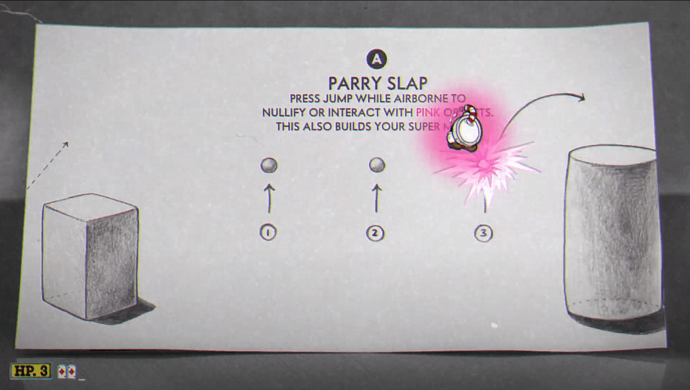
4.2 Ethics
Before any participation the test must read through the privacy notice, participant information and the consent for which they must sign. This insure they tester understand what they are signing up for. All data personal data collected will be securely stored on a OneDrive where only the researcher can access. The tester if informed that they can withdraw consent and their data at any time from the day of the test to 2 weeks after for any reason. Once the marks from the module are received all data accessible to the researcher will be permanently destroyed with only anonymous quotes being left in the report itself. Due to the test being brought to the participant in the form of a laptop the tester will be able to pick a place they feel comfortable doing it in. The risks of injury or harm to the test are virtually non-existent due to this fact alongside there being no physical requirements. The tester can also request breaks and can pause the game at any time or stop the test entirely when requested.

5. Practice
This section of the project will guide the reader through how each stage of the implementation worked and how each component was made being combined to create the final artifact. It will breakdown how the player component works, how the level design was iterated upon and how implementation of player feedback alongside research was used to create the second and final iteration of the artifact’s tutorial levels.

5.1 Initial Artifct Inspiration
The original artifact inspiration came from 2D side scrolling games such New Super Mario Bros. (Nintendo EAD, 2006). 2D side scrollers are often simple enough to learn by new players to not overwhelm them but can provide complex mechanics which require precise inputs and timings. This genre of games is also popular enough so many people will have at least heard of it due to its popularity. Nintendo states that New Super Mario Bros sold 30.8 million copies (Nintendo, n.d.) which is one of their all-time highest selling games for the Nintendo DS.

5.1.1 Parry Inspiration
While New Super Mario Bros DS gives a solid but simple move set more complex moves were desired to give players more control over their characters and add more complexity that can be scaled up were the artifact to be developed and iterated on more. The parry system used in Cuphead (Studio MDHR, 2017) called a “Parry Slap” and shown in figure 1 requires the player to press an input at the correct time to correctly parry. This system adds a layer of skill to the game and while optional in Cuphead will be used in a similar fashion to give the player movement in the artifact.
Fig 1: Tutorial level of Cuphead showing the “Parry Slap” system (Studio MDHR, 2017)

It was chosen that from this the artifact it will require the player to press an input at the correct time to give them a boost of height as if they were jumping from the ground. Unlike the inspiration the object chosen to parry off of was made larger to allow a more forgiving input timing.


5.1.2 Dash Inspiration
A dash is a movement feature that allows the player to “travel a distance many times the length of their body in a split second” (tvtopes, n.d.) oftern being used as a tool to move across large gaps or avoid danger. Celeste (Maddy Makes Games, Extremely OK Games, Lts, 2018) is another 2D platformer with a high level of movement. The player is given the option to dash in 8 different dirrections for a short distance. While taking inspiration from Celeste for its dash the decision was made to limit the dash to only the left and right dirrections due to the design choices of the levels which are the same size for each area. Increasing the dashes ability to move in any direction would reduce the creativity of each level with them having to pander to the extreme movement

5.1.3 Wall Jump and Slide
Many 2D side scrolling games have a wall jump and slide mechanic such as the afromentioned New Super Mario Bros and Celeste. This consists of jumping into a wall then when connect pressing jump again to push off the wall to the other side as shown in figure 2. Wall sliding is incorporated with this technique as holding the movement input into the wall makes the player character slowly slide down walls giving them more time to plan the next move. In the context of the game, both mechanics will be pivotal fetures in making sure the game has enough movement and control with skill expression but making it easy enough for the people testing who have no experience at all to handle.
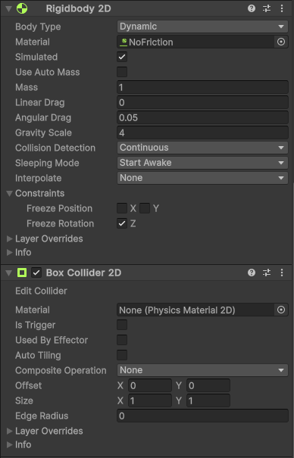
Fig. 2: Example of wall jumping in New Super Mario Bros
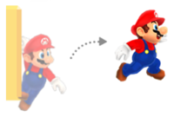

5.2 Player Set-Up

Now the core movement concepts have been chosen the next steps were to create a playable character within Unity version 2023.2.20f1 (Unity Technologies, 2024). Using the components and tools provided by unity and the documentation they provide (Unity Technologies, 2024) a playable character is created. The player model is the Unity cube sprite with a child sprite to symbolise the direction the player is facing as shown in figure 3.

Fig 3: Image of the player model from the artifact

Using this ismple method of creating a character skips the time that would have to be invested into creating/finding a player model and setting up the correct animations.

With the player model completed the next step is to give the player collision. This is done using Unity’s Box Collider 2D component (Unity Technologies, 2024) which provides the sprite with a box collider allowing it to interact with then environment. A Rigidbody 2D (Unity Technologies, 2024) component is attached to give physics such as gravity to the player as well as any physics-based behaviour like drag and mass. Finally, a C# script was attached which will control all the movement logic for the player which will be looked at deeper in the next section. These components are essential to creating simple player movement and provide all the tools to add extra movement abilities. Figure 4 shows the inspector from the project of the 2 components that let the player interact with other objects and have physics. The script for player movements will be explained deeper with how the logic works in section 5.3.
Fig 4: Image Unity inspector of the player

5.3 Player Movement Abilities
The next section will be going over how the player movement was implemented and any key points around it. As a reminder the main movement options the player has is horizontal movement, jumping, dashing, parrying, wall climbing and wall sliding. Each part was tested and iterated to get the feeling of the character correct as it was critical it felt good for the players. If any part of the movement was wrong then the flow of the game might have beem disrupted interupting with the playtest section of the project.
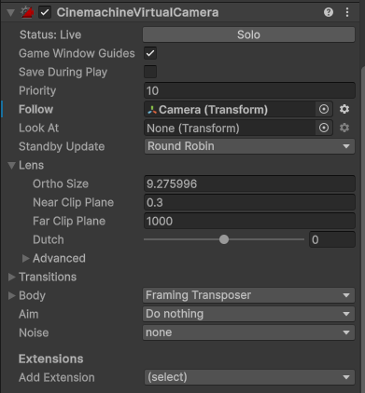

5.3.1 Basic Movement
The horizontal movement was created by retrieving the horizontal input using the Unity input system which gives a float between -1 and 1. There are a variety of different methods for moving the player character however the decision for this project was to use the Ridigbody 2D as a physics based approach often feels more fluid than moving the physicals characters world position. Moving the player with only the horizontal value would result in slow movement so a variable called speed was used that multiplies with the value stored in horizontal to apply a force to the Rigidbody 2D component. The pseudocode shown below is an example of how this works:

horizontal = input.horizontal
rb.velocity = Vector2 (horizontal*speed, rb.velocity.y

Early player feedback was considered when finding the correct speed value as it being too fast would lead to the player being able to complete jumps meant for other abilities and to slow reducing the enjoyment and overall feel of the game.

The horizontal movement would come under basic movement and with it comes jumping. The jump works in a similar way however requires a button input to work. When the input is pressed the same logic as the horizontal movement is applied however the force it applied positively on the Y axis. Once again, the power of the jump was tested to make sure the player couldn’t reach areas designed for. This way of implementing the jump always meant the player jumped the same height each time no matter how long the input was held down for. Once the first version of the jump was developed it was iterated upon by adding the feature of the player going higher the longer the input is held giving variance to each jump and giving the player more control over the character. It works by multiplying the Y axis velocity by half when the jump input is released.

5.3.2 Player Camera
With basic horizontal movement added a camera system was required to make sure the player character is always in view to the player. There are a few methods to create this like making the camera follow the player with code inside the player movement scripts however Unity has a plugin called Cinemachine (Unity Technologies, n.d.) which gives more control over the camera. Figure 5 shows the component with the various options that can be changed with the main ones being Ortho size and Follow.
Fig 5: Cinemachine settings from the Unity inspector

Ortho size changes the zoom of the camera with a higher value showing more of the surrounding area and the Follow section choosing which object the camera will follow. Initially the camera was set to follow the player character, but this was changed due to too much of the floor below the player being shown. The new point the camera followed was an empty object sat above the player solving the issue of most of the camera being full of dead space. This way of moving the camera was used until the level design changed from having one continuous level to multiple areas connected. The decision was made to have the camera static due to the new level designs and when the player enters a new zone the camera moves to the new point often in the centre of the room. During the last level there was a vertical section which meant that moving the camera from one point to another could be quite jarring to the player due to the rapid jumps between locations so the camera was changed to follow the players vertical height when in this section to make a more fluid transition between vertical sections of the map.

5.3.3 Wall Climb and Wall Slide
The wall jump and wall slide work in parallel with each other while keeping some of the already functioning code of the jump mechanic. Referring back to section 5.1.3 this mechanic provides the player with vertical movement options by allowing the character to interact with walls to reach areas not accessible with only jumping. The implementation of this feature uses an empty object found within unity which is made a child of the player model and positioned on the forward-facing side of the character shown in figure 6.
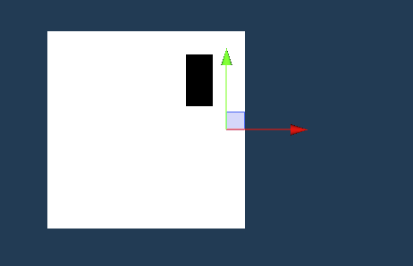
FIG 6: Image of the empty object placement for wall jumping checks

This object was named WallCheck with its positioning is important as it’s the side the player will be using to connect themselves to the wall for wall sliding. Looking into the code for this feature a Physics2D.OverlapCircle was cast from the position of the WallCheck which checks if there are any colliders within the radius of the cast. Private bool IsWalled is the function called through Update and returns the value of Physics2D.OverlapCircle however its current implementation will return true for any collider it touches so a LayerMask is created to allow certain object to be used as a wall slide surface when given the correct layer typing. The WallSlide function is in charge or controlling when the player should be moving down walls slowly. It checks if the player is connected to the wall, is not on the floor and the horizontal input isn’t equal to zero. If all requirements are met it slows the falling speed of the player and sets up the ability to wall jump which will be disgusted in the next section.

Implementing the wall jump was the next big step towards finishing the player movement and required the wall slide mechanic to be fully implemented due to the built-in checks for if a player is connected to a wall. The WallJump function is always being checked similarly to the WallSlide function however is triggered in a different fashion. While sliding the player can press the jump input again to conduct a wall jump however to prevent the player from jumping multiple times a check is made to see whether the player can wall jump again. Once the conditions are met the velocity of the Rigidbody 2D is changed to apply a chosen force to both the X and Y axis although the issue of the player jumping into the wall they are facing arises. To combat this the code used for turning the player around while walking was reused with the new wall jumping direction being multiplied by the X wall jumping power.

Finally, the dash was implemented using a Coroutine which allows code to be executed with delays inside which is core to making the dash work. The first implementation of the dash used a similar method to the player movement where the Rigidbody 2D’s horizontal velocity was multiplied by a value. This however did not stop players gravity and so dashing across large gaps became difficult. A change was developed to make the players gravity become zero while dashing to give a stronger feel to the dash as well as using it as a mechanic to stop the player from falling which was then used as a concept while developing the stages themselves. The Coroutine called a function that would set the players gravity scale to zero and then call the code to move the player. Once the dash was complete the gravity scale was reset to normal. A delay was then implemented to prevent spamming which was included in the Dash function. Once these mechanics were added some testing was conducted on a debugging level which found the feel of that dash wasn’t quite perfect due to the lack of air moves the player has access to. Adding a jump to the end of a dash gave players more control over their air movement giving a more consistent and fun gameplay experience.
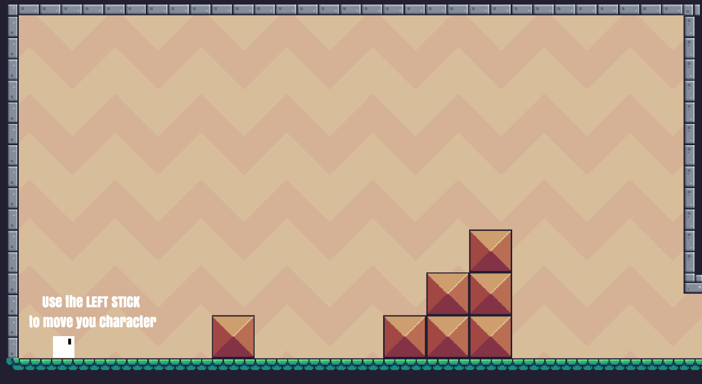

5.4 Level Design
Now the player controller is set-up the next steps were to develop a level. The level design went through multiple iterations each with different design priorities at the time and this section of the report will be going over what influence each iteration of the levels.

The first design of the level was designed around it being a single level that flows from one section to another in the same style as New Super Mario Bros (Nintendo EAD, 2006) due to its popularity as mentioned in section 5.1. The tutorial section of the project was simple and only showed text to tell people what to do (see Fig 7).
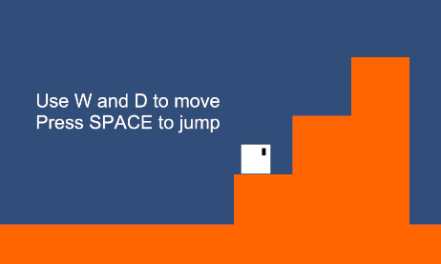
Fig 7: First jump tutorial section

The priority here was to get a strong base to work from and iterate while learning what features work best for this style of project and how it can help find answers to the projects research questions. During this stage of development, a keyboard control scheme was being used to control the character which got changed during the second iteration of the level. The core concepts of the movement and tutorial were in place, but the level designed after the tutorial section used for the player testing was considered too hard after peer testing in the early stages of development. Once peer testing had occurred the next iteration of the game levels started which took a pivot from the free moving camera following the player to a stage-by-stage level design with a static camera as mentioned in section 5.3.2 which allowed for more control over what each player could see. An asset pack found online was implemented alongside the new controller control scheme. This is a crucial stage in development as it sets the path for how the game is played. Even with these drastic changed the core concept of the tutorials stayed the same with text telling the player how to play the game. Figure 8 shows this best.
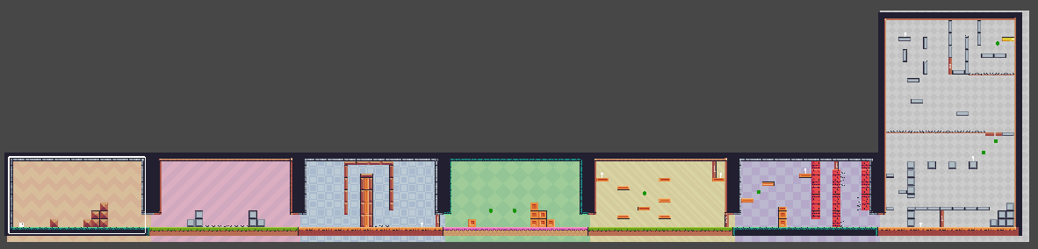
Fig 8: Image showing the level design
Using Unity’s Tilemap system (Unity Technologies, 2023) levels could be developed quickly with the tile pallet from the asset pack used. Improving the ways levels were created meant a level of consistency could be used to help answer the research question “What patterns do people pick up from either consciously or sub-consciously?” through using repeating shapes and patterns within the levels. This approach ended up with the level shown in figure 9 showing the outcome before the proper player testing occurred.
Fig 9: All levels from before the player testing

Post-playtest and research, plenty of information was uncovered which will be talked about deeper in section 6 with the outcomes of the project however some of the influences for the final changes will be explained to give context and reasoning as to why they were changed. The first key change was with the way the game showed the player new information. While playing a pattern was noticed in that certain players would miss the text telling them what to do or misunderstand what it was asking of them. One tester said “The text was sometimes hard to see with the background colours” adding that making the text a more noticeable colour would help make it more obvious. A different tester mentioned “I don’t really understand what the game wants me to do” while trying to complete the parry section. Both comments about this section of the tutorial as well as the other notes collected impacted how the text was changed. To begin with it was given a more vibrant colour that stood out among all backgrounds and made it harder for players to miss. Each text prompt was made bold and given a background increasing its visual appearance. Text prompts also had new explanations given to them increasing the likelihood of the player understanding what is asked of them.

With the changes to the text complete using the research found in the literacy review from section 3.1 saying how videos can explain complex text (LearnDash Collaborator, 2021) videos showing what the player needs to do were created. Each one was given a black border to stand out (see Fig 10) and covers the basics of what they are supposed to do while giving them the freedom to try themselves for the kinaesthetic learners. The combination of these hopes to improve the learning experience and long-time retention of information when playing through the rest of the level.
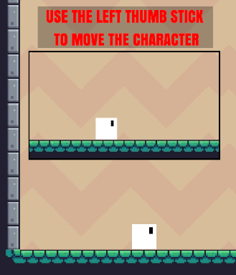

Fig 10: Image showing examples of the new text and videos

The final major changes were to the tutorial level section themselves. Each one was recreated to try and give patterns for the players to recognise and understand what they are required to do to progress. The best example of this is with the introduction to the wall jump/slide section that teaches about the wall jump and slide as well as the new button and door feature and the parry tutorial level. Originally the first level made the player complete the wall jump and slide section, press a button and move onto the parry section which contained only the parry. This promotes a lack of learning and is a very one and done way of teaching. The new tutorial levels now involve previous mechanics which are required to finish the level.
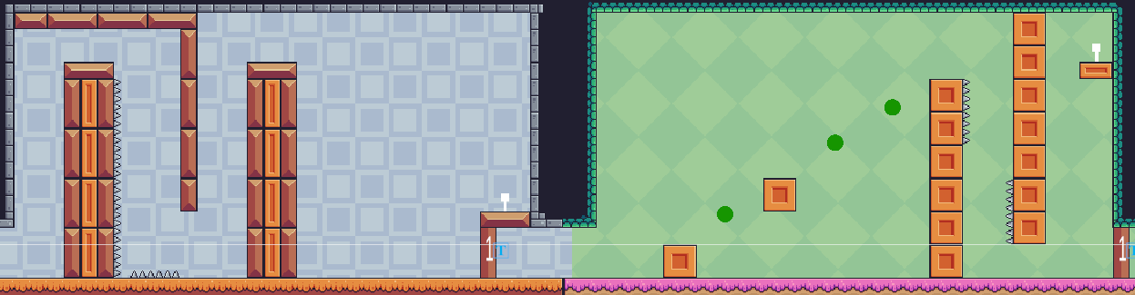
Fig 11: Image of the new tutorial sections for wall jumping/sliding and parry

Figure 11 shows how the new levels can promote learning and remember the new features taught to the player. The left portion is teaching how to wall climb and wall slide and through repetition hopes to create a pattern of when a player has to use either mechanic. The new iteration also provides the information of being able to use the walls of the area to jump from. The large gap between the top of the second pillar and the button platform is there to promote use of the dash. Without it the player cannot reach the button and if the player reaches the bottom, they will have to use the jump at the end of the dash to get back up. Looking into the other half of figure 11 wall jumping and sliding is required to reach the button again which promotes repetition and creating a pattern for the player that they need to use those mechanics to complete the level.
Finally, while the spikes in iteration one of the artifact had a text prompt saying they must be avoided, the decision was made to not include them in the second iteration. This was due to the research from the literacy review about kinaesthetic learning talking about how falling into a pit or in this case the spikes is a form of leaning (Veli-Matti Karhulahti, 2013). Once the player has hit the spikes once they will realise that it’s a bad thing to do and will avoid it without needing to be told.

6.1 Discussing Play Test Feedback
The main outcome of the project was the final iteration of the project which combines the research from the literacy review in section 3 and the player testing notes and feedback collected. The first iteration of the tutorial of the level was purely designed around telling players the controls and letting them figure it out what to do through trial and error. Giving a player the bare minimum and asking them to tell the researcher their current though process helped a lot in getting more inciteful information about what the player felt like they were missing. The first major outcome from the playtest involved the tutorial text and how it conveyed information. It only told the player which buttons to press in order to move the character and let them figure out the rest of the mechanics themselves. From this a correlation between the players previous experience and average playtime and their understanding the tutorial text arose with those who have played the same genre of games requiring less help than those who have no experience. This was an expected result and thus the notes taken on those with less experience were weighted more heavily when taking them into account in iteration 2 which is talked about more in section 6.2.

The next outcome was that player ended up forgetting moves in particular the dash and dash jump. Iteration one only provided one opportunity of teaching how the dash works and combines both the dash and dash jump together creating confusion for players who completed the jump without using the jump dash at the end. The dash isn’t utilised until a few sections after which is required to reach a gap too large for a regular jump. Once again, the participants with experience found this out quickly and even used the dash for movement within the level but those without required assistance from the researcher to know what to do next. Once reminded there was still very little use of the dash throughout the levels and some participants would overrun the time allowed for the level due to this. Knowing this it was noted that a change to the level design to create repetition would be required to force the player to use this mechanic.

Finally, the last major outcome taken from the play test was that of the parry and the confusion surrounding the feature. While common in games new players may not have seen the feature before. It was noted by a tester that “I don’t get what the text is telling me to do” and that even after an explanation the understanding still wasn’t there. This tells the researcher that text alone wasn’t sufficient for the more complex areas of the game. To avoid confusion research from the literacy test was taking about visual learning and applied to the second iteration.
6.2 Artifact Tutorial Iteration 2
The outcome of the second iteration was a result of the play test feedback and research providing an improved tutorial level with the learning theories applied to it. This iteration provides a clear demonstration how the different types of learning theories can be used in conjunction with one another to create a clear and concise tutorial with information that is easy to understand and level designs that cause the players to create patterns improving the retention of the information. The updated text telling the player controls solves the issues of misunderstanding what is being asked of them by making it more detailed and giving it a more visible appearance makes the issue of text being missed a lower chance of happening. Using this alone was proven to be insufficient at certain sections like the parry mentioned in section 6.1 with the solution being the use of videos showing the player what is being taught to them. This incorporates the visual learning style from section 3.1 allowing the video to do the teaching and the text to give context and support. Dashing being forgotten or underused was solved using level design making it so the player had to use it more often before the tutorial ended. This repetition meant that through kinaesthetic learning researched in section 3.2 was being used as the player was learning when to use the dash by doing the action. The wall jumping and wall sliding sections we reworked to help create patterns whenever it was required. The repetition of each segment meant that after repeating it multiple times and seeing the general shape that wall jumping used the player would either sub-consciously or consciously recognise when they had to use that feature. The change in level design also taught the player about using the edges of the area to wall jump which, while not said directly, taught them through doing in the hope they keep that information.

6.3 Discussing Research Questions
The first question from section 2 is asking what are the most effective proven ways of teaching. Through the research conducted I the literacy review there isn’t one method that rules them all. While it was discovered that there are larger groups of people who learn in a specific way such as visual learners there are also groups of people who struggle to follow along with this style. It was discovered that the most efficient way of learning is a combination of multiple different learning styles that can help teach the information together by filling in missing context that the other type might miss.
The second question was how do different people learn has been answered using the research from section 3 however a deeper exploration into this topic could be taken. This report focused mostly on three different types of learning with that being visual, kinaesthetic and pattern-based approaches whiles there are a variety of other different ways people learn. Referring back to section 3 Bay Atlantic University says there are 8 different learning styles (Bay Atlantic University, 2025) which if the project were to be taken further could be looked at to get more information about how humans learn.
The third question was looking at how do people of different ages learn. While the information was taken in about the player ages during the play tests the range of ages were not substantial enough to provide the data required to the answer to this question. If this project were to be taken further, more research would be needed to be done into how ages effects learning and linking it to past experiences. Looking back at the project more time would have been required into researching learning in age groups however this could have increased the scope of the project too far due to it being its own area of research.
The final question was looking at what patterns do people pick up from either consciously or sub-consciously with a focus on finding out if having patterns within the level promotes learning. The final iteration demonstrates the practice of using a defined set of rules the game must follow in order to create these patterns and using visuals to promote them. The results of the play test while not showing learning patterns did show how the variety of skill levels played quite similarly to each other.

6.4 Achievements and Improvements Required
The artifact achieves its goal of presenting the process and iteration of a tutorial stage and how other developers can take the ideas presented within the project and expand on them to create something more suited to their own projects. It is a guide on how the combination of different learning theories and techniques combine to give an overall more interactive and engaging experience when showing new information. Outside of the context of games the information gathered can also be used in other aspects of learn such as in schools and universities. While the project perhaps doesn’t go into the depth required for these large-scale versions of teaching it can inspire teachers and lecturers to try out new methods of teaching to reach all the different ways people learn.

While achieving many of the requirements there are still flaws within the project. An obvious issue would be the sample size acquired. A total of 15 participants conducted the test and while flaws in the project tutorial stages appeared it wasn’t able to present a deeper understanding of how different people work around the information provided. The lack of participants meant patterns between ages, experience and average play time couldn’t be used to create graphs or a higher representation of each category. Another flaw would be the number of mechanics present in the game. While enough to produce results increase the mechanics and introducing new ways they can be used together to create new learning experiences for more experienced players would have led to seeing how even with more play time and knowledge of the games genre people can still learn.

7. Conclusion and recommendations ~400
Overall, the project had success in researching methods to help game developers improve the way new information is provided and retained with inexperienced players in video games. The research conducted can be taken and applied to future projects where new information needs to be presented in a way that anyone with any experience level can interpret and understand the new features or requirements being asked of them. Practically, the artifact provided gives a strong example of how these researched ideas can be applied in other areas within the subject of helping new or experienced players learn games. The combination of the different learning types being applied simultaneously gives a varied range of ways information can be presented making sure no matter what sort of method the players learn from more efficiently from, such as visual or kinaesthetic, they will have the ability to learn and retain the new information. Outside of this research project the methods of learning can also be applied to other areas of education. Using the example of teaching about medical body parts in section 5.3, lecturers in the field could present the new information through text to teach the core of the topic with photos to back it up for visual learners but then bring in aspects of a kinaesthetic approach by letting the students create models to physically apply the knowledge they’ve learnt through reading and seeing. The benefit of using games as an area to conduct tests into learning is that there will always be a wide enough range of participants ranging from no experience to doing the activity daily. Even those with experience from previous games may not have played the genre presented in the test which could give more feedback on patterns of what players who play similar games do.

Were the project to be continued in development there are a few next steps to take. While the original project had playtesting the number of participants were limited. A wider more varied audience would give a deeper understand of any missing features that may have been overlooked. Another area of focus would be seeing how the methods applied to this project’s artifact would translate into a different game genre such as a first-person game. Referring back to the introduction of section 3 more learning ideas and theories could be researched to reach a wider range of players and helping to make sure there is as little misunderstanding as possible. Finally, more research into learning at different ages should be looked into. While a research question within this project, it was not looked into thoroughly enough to find a proper conclusion to the answer.

In conclusion the project has found answers to the majority of the research questions while finding key information to answer the main project question which can be developed upon and implemented to areas such as student education.

8. References
Matther Barr and Alicia Copeland-Stewart(May 6, 2021) Playing Video Games During the COVID-19 Pandemic and Effects on players’ Well-Being. Available from: https://journals.sagepub.com/doi/full/10.1177/15554120211017036#core-collateral-self-citation [Accessed last: Apr 3, 2025]

Matthew Broughton( Mar 19, 2020) Tencent Revenue Up 21%; Video Game Usage Amid Covid-19. Available from: https://www.thegamingeconomy.com/2020/03/19/tencent-revenue-up-21-video-game-usage-rises-amid-covid-19/. [Accessed last: Apr 3, 2025]

Firaxis Games (Oct 21, 2016) Sid Meier’s Civilization® VI [Video Game]

Bay Atlantic University (Mar 7, 2024) 8 Types of Learning Styles: The Definitive Guide. Available from: https://bau.edu/blog/types-of-learning-styles/. [Accessed last: Apr 22, 2025]

Wileman, R.E. (1993) Visual Communicating. Englewood Cliffs, NJ: Educational Technology Publications. [Accessed last: Apr 22, 2025]

Top Hat (Sept 16, 2019) Visual Learning Definition and meaning. Available from: https://tophat.com/glossary/v/visual-learning/. [Accessed last: Apr 22, 2025]

LearnDash Collaborator (June 1, 2021) 6 Elements of an Outstanding Tutorial Video. Available from: https://www.learndash.com/blog/6-elements-of-an-outstanding-tutorial-video/#:~:text=6.-,Be%20generous%20with%20your%20visuals.,instructional%20material%20for%20your%20learners. [Accessed last: Apr 22, 2025]

Martina A. Rau (Apr 22, 2016) Conditions for the Effectiveness of Multiple Visual Representations in Enhancing Psychology Review. Available from: https://link.springer.com/article/10.1007/s10648-016-9365-3#Abs1. [Accessed last: Apr 22, 2025]

Alexander Eitel, Katharina Scheiter, Anne Schüler (Mar 25, 2013) How Inspecting a Picture Affects Processing of Text in Multimedia Learning. Available from: https://onlinelibrary.wiley.com/doi/10.1002/acp.2922. [Accessed last: Apr 22, 2025]

Bay Atlantic University (Sept 20, 2024) What is A Kinaesthetic Learner. Available from: https://bau.edu/blog/what-is-a-kinesthetic-learner/. [Accessed last: Apr 22, 2025]

Hernandez JE, Vasan N, Huff S, Melovitz-Vasan C (Aug 27, 2020) Learning Styles/Preferences Among Medical Students: Kinesthetic Learner’s Multimodal Approach to Learning Anatomy. Available from: https://pmc.ncbi.nlm.nih.gov/articles/PMC8368716/#Abs1. [Accessed last: Apr 22, 2025]

Brame CJ. (Winter, 2016) Effective Educational Videos: Principles and Guidelines for Maximizing Student Learning from Video Content. Available from: https://pmc.ncbi.nlm.nih.gov/articles/PMC5132380/. [Accessed last: Apr 22, 2025]

Samba Recovery (Mar 4, 2025) Average Human Attention Span Statistics & Facts [2024]. Available from: https://www.sambarecovery.com/rehab-blog/average-human-attention-span-statistics. [Accessed last: Apr 22, 2025]

Lin Li-Hsin, Narender Rainita, Zak Paul J (Dec 13, 2022) Why people keep watching: neurophysiologic immersion during video consumption increases viewing time and influences behaviour. Available from: https://www.frontiersin.org/journals/behavioral-neuroscience/articles/10.3389/fnbeh.2022.1053053/full. [Accessed last: Apr 22, 2025]

Joe Tranquillo (Jun 22, 2008) Kinesthetic Learning in the Classroom. Available from: https://peer.asee.org/kinesthetic-learning-in-the-classroom. [Accessed last: Apr 22, 2025]

Sarah N, Brin G (Jun 27, 2022) Exploring the Benefits of Art-Based Kinesthetic Activities in the College Classroom. Available from: https://www.tandfonline.com/doi/epdf/10.1080/87567555.2022.2088676?needAccess=true.
[Accessed last: Apr 22, 2025]

SimpleK12 Staff (Feb 17, 2025) Kinesthetic Learning Style: Definition, Characteristics & Benefits in 2025. Available from: https://www.simplek12.com/learning-theories-strategies/kinesthetic-learning-style/. [Accessed last: Apr 22, 2025]

Alina-Mihaela Busan (Mar 29, 2014) Learning Styles of Medical Students – Implications in Education. Available from: https://pmc.ncbi.nlm.nih.gov/articles/PMC4340450/#:~:text=In%20the%20general%20population%2C%20the,%25%20auditory%20and%205%25%20kinesthetic. [Accessed last: Apr 22, 2025]

Veli-Matti Karhulahti (Sept, 2013) A Kinesthetic Theory of Videogames: Time-Critical Challenge and Aporetic Rhematic. Available from: https://gamestudies.org/1301/articles/karhulahti_kinesthetic_theory_of_the_videogame/. [Accessed last: Apr 22, 2025]

Nintendo EAD (May 16, 2006) New Super Mario Bros. [Video Game]. Nintendo.

Clemmy Ralph (Jun 14, 2022) 65% of People Prefer Visual Learning, Is teaching Keeping Up?. Available from: https://blog.videoscribe.co/65-of-people-prefer-visual-learning-is-teaching-keeping-up#:~:text=Only%205%25%20of%20respondents%20stated,when%20attempting%20to%20retain%20information. [Accessed last: Apr 22, 2025]

VARK (Aug 14, 2024) The VARK Modalities: Visual, Aural, Read/write & Kinesthetic. Available from: https://vark-learn.com/introduction-to-vark/the-vark-modalities/ . [Accessed last: Apr 22, 2025]

Anon (no date) Pattern Recognition. Available from: https://c8sciences.com/about/8ccc/pattern-recognition/. [Accessed last: Apr 22, 2025]

Theodoridis, S and Koutroumbas, K (Feb 24, 2006) Introduction. Pattern Recognition [Online] Orlando, FL: Academic Press, Inc, pp. 1. [Accessed last: Apr 22, 2025]

Anon (Aug 23, 2024) Exploring Cognitive Skills: Pattern Recognition. Available from: https://www.happyneuronpro.com/en/info/what-is-pattern-recognition/. [Accessed last: Apr 22, 2025]

Robert C Barkman (May 19, 2021) Why the Human Brain Is So Good at Detecting Patterns. Available from: https://www.psychologytoday.com/us/blog/singular-perspective/202105/why-the-human-brain-is-so-good-detecting-patterns. [Accessed last: Apr 22, 2025]

Jennifer Logan (Mar 13, 2023) What is the Neocortex?. Available from: https://www.news-medical.net/health/What-is-the-Neocortex.aspx. [Accessed last: Apr 22, 2025]

Miryam Naddaf and Nature Magazine (Sept 27, 2024) How Your Brain Detects Patters without Conscious Thought. Available from: https://www.scientificamerican.com/article/how-your-brain-detects-patterns-without-conscious-thought/#:~:text=The%20human%20brain%20is%20constantly,brain%20tissue%20for%20medical%20reasons. [Accessed last: Apr 22, 2025]

Ohio State University (May 31, 2018) This is your brain detecting patterns. Available from: https://www.sciencedaily.com/releases/2018/05/180531114642.htm. [Accessed last: Apr 22, 2025]

Unity Technologies (April 25, 2024) Unity version 2023.2.20f1. Available from: https://unity.com/releases/editor/archive [Accessed last: Apr 26, 2025]

Nintendo (n.d.) Top Selling Title Sales Units. Available from: https://www.nintendo.co.jp/ir/en/finance/software/ds.html. [Accessed last: Apr 26, 2025]

Studio MDHR (Sept 29, 2017) Cuphead. Available from: https://store.steampowered.com/app/268910/Cuphead/. [Accessed last: Apr 26, 2025]

Tvtropes (n.d.) Video Game Dashing. Available from: https://tvtropes.org/pmwiki/pmwiki.php/Main/VideoGameDashing [Accessed last: Apr 26, 2025]

Unity Technologies (April 25, 2024) Unity Documentation. Available from: https://docs.unity3d.com/2023.2/Documentation/Manual/ManualVersions.html. [Accessed last: Apr 26, 2025]

Unity Technologies (April 25, 2024) Box Collider 2D component reference. Available from: https://docs.unity3d.com/2023.2/Documentation/Manual/class-BoxCollider2D.html. [Accessed last: Apr 26, 2025]

Unity Technologies (April 25, 2024) Rigidbody 2D. Available from: https://docs.unity3d.com/2023.2/Documentation/Manual/rigidbody2D.html. [Accessed last: Apr 26, 2025]

Unity Technologies (n.d.) Cinemachine. Available from: https://unity.com/features/cinemachine. [Accessed last: Apr 26, 2025]

Unity Technologies (Jan 31, 2023) Introduction to Tilemaps. Available from: https://learn.unity.com/tutorial/introduction-to-tilemaps#. [Accessed last: Apr 26, 2025]

Appendix A: Project Log (not included in word count)
Appendix B: Project Timeline (not included in word count)

Appendix C: Assets used in the Project (not included in word count)
This is a list of project assets: all source materials used in the project. Clearly state which were produced by yourself and which were not. If not produced by yourself, include their reference, and status with regard to copyright/ creative commons licensing.
Further Appendixes D, E … if applicable* (not included in word count)
What could go here?
- Ethics: participant info sheets, consent form, interview questions, anonymized matrices, other anonymized summaries or analyses
- Any important design documents too large to insert in the main text
- Any important code sections not already on GitHub
- Any impotant large tables or diagrams
- Other relevant materials

*only insert meaningful materials here, please don’t just bulk this report up. Your main text should be able to stand on its own, without relying on information contained in appendixes. Check with your supervisor beforehand.

